6/2/2026
Matthew Borella
Premier Worksite Benefits
700 Kinderkamack Rd
Ste. 205
Oradell, NJ 07649

Dear Matt:
Attached are the Monthly Premium Remittance Reports for the month of May 2026. Our accounting of the funds received totaled $289,723.19 which agrees to the penny with both the Monthly Reports and our database. Please distribute the funds as follows:

AMALGAMATED: $ 92,777.64 (41% of Premium collected in May-2026)
HPA Commission: $133,509.29 (59% of Premium collected in May-2026)
AHA Dues: $ 63,436.26 (Membership dues collected in May-2026)
Premier (Fee): $ 5,200.00 (Taken from HPA Commissions above)
Total: $289,723.19

These figures have been carefully reviewed and double-checked with each of the transaction types from which the figures were originally calculated.
Your prompt submission of HPA's Commissions by wire to our Bank of America account is greatly appreciated. I realize the total submitted to HPA might be slightly different than the $133,509.29 noted above. This is due to the current agreement between Premier Worksite Benefits and HPA and the current method of reconciliation. I look forward to receiving your documentation explaining the differences for our records. Also, please wire the money for AHA into the Wells Fargo account.
Very Sincerely,
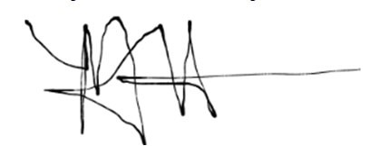
Melinda Harris
Office Manager
Home Protection Associates
American Homeowners Association

